UID LAB EXERCISE 5

Task Analysis and User flow

Sheryl Katrina.M

230701310

**E-commerce Website User Flow Documentation:**

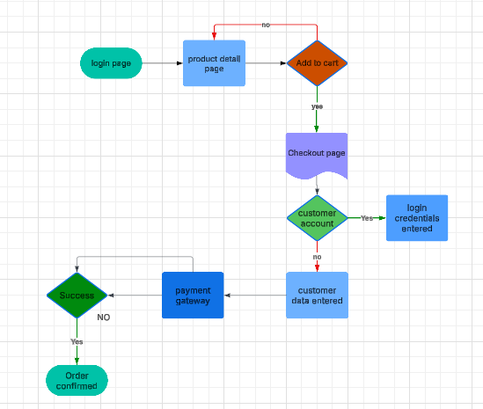

**1. Login Process**

* Users start at the login page.
* They enter their credentials (email/username and password).
* If credentials are correct, they are redirected to the homepage.
* If incorrect, an error message is shown, and users can retry or reset their password.

**2. Product Browsing and Selection**

* Users navigate to the product detail page.
* They can explore product descriptions, images, reviews, and pricing.
* They decide whether to add the product to the cart.
* If they choose not to add, they can continue browsing.

**3. Adding to Cart**

* When a user selects a product, they click 'Add to Cart'.
* If logged in, they proceed to checkout.
* If not logged in, they are prompted to log in before proceeding.

**4. Checkout Process**

* Users are directed to the checkout page.
* They enter or confirm customer details such as shipping address and contact information.
* If they already have an account, the saved information is auto-filled.

**5. Payment Processing**

* Users select a payment method (Credit Card, PayPal, etc.).
* They are redirected to a secure payment gateway.
* If payment details are valid, the transaction proceeds.
* If payment fails, users are prompted to retry or use another method.

**6. Order Confirmation**

* If payment is successful, the order is confirmed.
* Users receive an order confirmation notification via email/SMS.
* They can track their order in the 'My Orders' section.

**7. Post-Purchase Support**

* Users can review orders, request returns, or contact customer support.
* The system updates users about order status (shipped, delivered, etc.).
* If users face issues, they can raise a complaint or request refunds.

This structured process ensures a smooth, secure, and user-friendly shopping experience.

**Explanation of Shapes in the Flowchart and Their Purpose**

Each shape in the flowchart serves a distinct role in the representation of the e-commerce checkout process. Below is a breakdown of the shapes used and why they are used:

**1. Oval (Terminator) - Start/End Points**

* **Examples in the Flowchart:**
  + "Login Page"
  + "Order Confirmed"
* **Purpose:**
  + Represents the starting or ending point of the process.
  + Used to define where the process begins (login page) and where it ends (successful order confirmation).

**2. Rectangle (Process) - Actions/Steps**

* **Examples in the Flowchart:**
  + "Product Detail Page"
  + "Checkout Page"
  + "Customer Data Entered"
  + "Payment Gateway"
* **Purpose:**
  + Represents a specific action or step in the process.
  + These are the actual tasks users perform, such as viewing products, entering customer details, or making a payment.

**3. Diamond (Decision) - Conditional Checks**

* **Examples in the Flowchart:**
  + "Add to Cart"
  + "Customer Account"
  + "Success"
* **Purpose:**
  + Represents a decision-making step where the process can follow different paths based on conditions.
  + Example: In "Add to Cart," if the user chooses not to add a product, they return to the product detail page.
  + "Customer Account" checks if the user is logged in or needs to enter credentials.
  + "Success" determines if the payment and order confirmation process is completed.

**4. Parallelogram (Input/Output) - User Inputs**

* **Examples in the Flowchart:**
  + "Login Credentials Entered"
* **Purpose:**
  + Represents user input or data entry required to proceed.
  + Example: Users need to enter login credentials before proceeding to checkout.

5.Curved Rectangle:

**Meaning of the Checkout Page Symbol:**

* This shape is commonly used to **represent a predefined process or sub-process.**
* It indicates that the **checkout page is an important stage in the workflow** where multiple actions occur, such as reviewing the cart, providing shipping details, and selecting payment options.
* The **curved edges** often suggest that it is a **major step or a separate module** within the overall system.

Task Analysis:

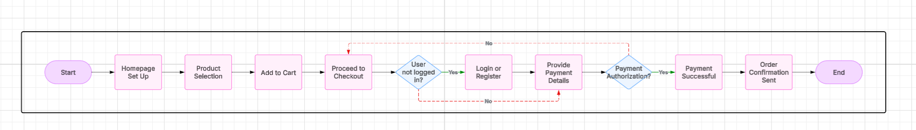

**Task Flow Analysis of the E-Commerce Checkout Process**

The given diagram represents a structured workflow of an e-commerce checkout process, detailing each step a user follows from visiting the homepage to completing a purchase. Below is a detailed breakdown:

**1. Start (Process Initiation)**

* The process begins when a user initiates interaction with the e-commerce platform.

**2. Homepage Setup**

* The system loads the homepage.
* Displays products, categories, and user interface elements.
* User can browse available products.

**3. Product Selection**

* The user selects a product of interest.
* The system may display details such as price, description, and availability.

**4. Add to Cart**

* The user adds the selected product to their shopping cart.
* The cart updates dynamically to include added items.
* Users can continue shopping or proceed to checkout.

**5. Proceed to Checkout**

* The user decides to proceed with the purchase.
* The system redirects to the checkout page.

**6. Check User Login Status**

* Decision point: *Is the user logged in?*
  + **If Yes** → Move to "Provide Payment Details".
  + **If No** → Redirect to "Login or Register" page.

**7. Login or Register (if applicable)**

* If the user is not logged in:
  + The system prompts the user to log in or create an account.
  + Once authenticated, proceed to the next step.

**8. Provide Payment Details**

* The user enters payment information (credit card, PayPal, etc.).
* The system validates payment details before proceeding.

**9. Payment Authorization Check**

* Decision point: *Is the payment authorized?*
  + **If Yes** → Proceed to "Payment Successful".
  + **If No** → Redirect back to "Provide Payment Details" for correction or alternative payment method.

**10. Payment Successful**

* The system confirms that the payment is successful.
* A confirmation message is displayed.

**11. Order Confirmation Sent**

* The system generates an order confirmation.
* An email or notification is sent to the user with order details.
* The order is logged in the system for processing.

**12. End (Process Completion)**

* The transaction process ends successfully.